

**Software Engineering Department**

**Braude College**

Capstone Project Phase B

**Angel Hands – Sign language Learning Game**



**Project Number 24-2-D-39**

**Advisor**: **PhD. Sulamy Moshe –** [MosheSu@braude.ac.il](mailto:MosheSu@braude.ac.il)

**Students**: Eitan German – [eitan.german@e.braude.ac.il](mailto:eitan.german@e.braude.ac.il)

Dolev Almog – [dolev.almog@e.braude.ac.il](mailto:dolev.almog@e.braude.ac.il)

Abstract 4

1. Introduction 4

2. Development Process 5

2.1 Designing a ASL recognition model 5

2.2 Collection of data 6

2.3 Syncing the model with the game 7

2.4 Development of the unity game 7

2.5 Diagrams 8

2.5.1 Architecture Diagram 8

2.5.2 Activity Diagram 9

2.6 Testing plan 10

2.6.1 Usability Testing 10

2.7 Challenges 12

2.7.1 Multi Process Web Camera Access 12

3. User Guide 13

Recommended System Requirements 13

Getting Started 13

3.1 Angel Hands Unity Game 13

3.2 Model Trainer Application 19

Setting up the trainer application 19

3.2.1 Data Acquisition methods: 19

3.2.2 Data management 22

3.2.3 Training the model 23

3.2.4 Testing the model 24

3.2.5 The ASL Recognition Service 24

3.2.6 Extra 25

4. Maintenance Guide 25

4.1 Game Maintenance 25

4.1.1 Updating the sign language Model 25

4.1.2 Expanding the game 25

4.1.3 Game Modules 26

4.1.4 PlayFab Database and login API 27

4.2 ASL Model Maintenance 29

4.2.1 Main Application 29

5. Results & Conclusions 30

5.1 Further Improvements 30

6. References 30

7. GitHub Link 31

# Abstract

Angel Hands Is an educational video game that focuses on sign language learning for children and adults. The game’s goal is to teach its users how to speak in the American sign language (ASL).

It uses computer vision to capture and detect the user’s hands, it uses machine learning to analyze the signs that the user is presenting to the camera of the computer/ mobile phone/ tablet.

To make the game more attractive it incorporates adventure-themed elements and exciting challenges that aim to keep the user motivated and excited to learn.

The game is designed for users of all knowledge levels and experiences in ASL by incorporating multiple difficulty levels for the user to choose from and thus stays relevant even for the more experienced ASL signers.

# 1. Introduction

In today's interconnected world, the importance of effective communication cannot be overstated. Yet, for millions of individuals, traditional methods of communication may not always be accessible. Language barriers can isolate individuals and hinder their ability to express themselves fully, leading to feelings of frustration and exclusion. In such instances, alternative forms of communication, such as sign language, can bridge these gaps and empower individuals to connect with others in meaningful ways.

Recognizing the significance of sign language as a vital means of communication, we introduce "Angel Hands," an innovative educational video game designed to facilitate the learning of American Sign Language (ASL) for both children and adults. This project represents a fusion of technology and education, leveraging the immersive capabilities of modern gaming platforms to make language learning engaging, interactive, and accessible to a broad audience.

At its core, "Angel Hands" seeks to revolutionize the way ASL is taught by harnessing the power of computer vision and machine learning technologies. Through the use of computer vision, the game can detect and analyze users' hand movements in real-time, providing immediate feedback and guidance as they navigate through the intricacies of ASL. This dynamic approach not only enhances the learning experience but also accommodates users of varying proficiency levels, from beginners to advanced learners.

In addition to its innovative technological features, "Angel Hands" distinguishes itself through its captivating gameplay mechanics. By incorporating adventure-themed elements and exciting challenges, the game transforms the learning process into an immersive journey filled with discovery and excitement. From solving puzzles to embarking on quests, users are propelled into a world where learning becomes an adventure, fueling their motivation and enthusiasm to master ASL.

Furthermore, "Angel Hands" prioritizes inclusivity by offering multiple difficulty levels tailored to accommodate users with diverse learning needs and experiences. Whether someone is just beginning their ASL journey or seeking to refine their skills, the game provides a supportive and engaging environment for continuous learning and growth.

In essence, "Angel Hands" represents more than just a video game; it symbolizes a commitment to breaking down barriers and fostering greater inclusivity through the power of technology and education. By empowering individuals to learn and communicate in ASL, we hope to not only enrich their lives but also promote understanding and acceptance in our global community. Join us on this transformative journey as we embark on an adventure of learning, connection, and empowerment with "Angel Hands."

The sign language recognition is the main feature of the project, which enables the game to recognize the signs the user is presenting to the camera.

# 2. Development Process

In the Development of “angel Hands”, a 3d Unity Game, aimed to teach sign language.   
we implemented an agile methodology to develop our game, where at the beginning of the semester we devised a work plan and each sprint we deployed a working version of the game and reviewed our progress to that point and assigned the tasks for the following week.  
The development process was split into 6 main parts that at the completion of them we ended up with an amazing application that was both versatile and effective.

## 2.1 Designing a ASL recognition model

One of the most important aspects of our game was to create a model that would accurately and quickly recognize signs from the user, so we started by trying to first create a model that would allow us to learn and detect signs from the user’s camera.

We started by evaluating various methods to design the model. The first one we examined was the YOLOX model. We initially found a pretrained model that worked exceptionally well, the only problem was that it contained only 18 signs, and since this model takes pictures as its input to train it also meant that we need a very large dataset with a variety of images from different people and locations with varying lighting conditions. we tried adding new signs but fell short since it was impossible to collect the amount of data required to train a model like that. Since we couldn’t expand the model, this wasn’t the right solution for us.

Since we weren’t satisfied with the results, we started looking for something else, that was when we found out about google holistic landmarks. It is a tracking solution that marks the main landmarks and key features of the human body and basically allows us to focus on what matters, which for us was the pose and the movements the user made with his hands. By using google holistic landmarks we were able to create a new model that would learn based on the landmarks extracted instead of the video feed.

Using Landmarks greatly reduced our data requirements. It also meant we could train a model within minutes with a high accuracy.

We implemented an LSTM model that would take as an input the google holistic landmarks after concatenating all the different types of landmarks into an np array that was then fed to the model.

One very important aspect of the new model we wanted was the ability to detect not only static pictures as a sign but also movements, since sign language is a very special and truly extraordinary language with very intricate details. Our model was required to take bursts of 30 frames as its input to detect movements. This was a great breakthrough since we finally had something that could be used realistically within our game.

Pose Landmarks[1] Hand landmarks[2]

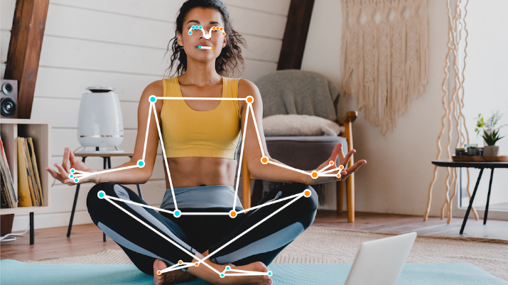 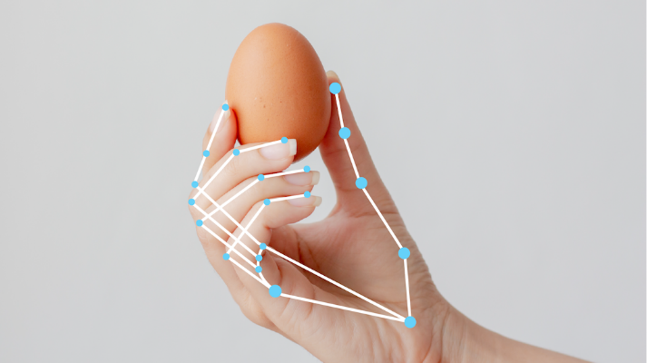

Face Landmarks[3]

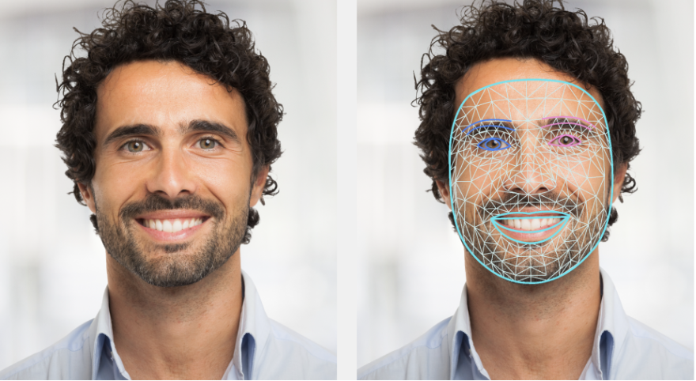

## 2.2 Collection of data

The main challenge of any machine learning algorithm is a good data source, which we didn’t have at the beginning, we found a dataset from Microsoft called “MS-ASL”, at first it was daunting since the dataset was composed of over 16000 entries for many signs. But the biggest fallback was that it was not composed of images or videos, it was a bunch of labels and YouTube links to videos of people showing how to do each sign and the data was scattered and unorganized. fortunately for us it also included the start time of each sign and the end time which allowed us to focus only on the signs, we wrote a script that grouped the different videos by the sign each video teaches and with the help of the application we designed we were able to take a list of labels and video links and quickly download the videos and train directly on videos from YouTube.

This mean that our lack of data was over, and we could quickly collect data and expand our model.  
we will elaborate more on how the application works and how to train the model and collect the data.

## 2.3 Syncing the model with the game

Since nowadays it is very accessible and simple to quickly design and implement machine learning algorithms and models using python it was a no brainer for us to use python as our language for the model. But unity uses C# as its language for the backend development, so we encountered a new problem of running the sign language recognition model alongside with the game. Our solution was to create a local “server” that would transmit the detected sign along with metadata on the accuracy of the detected sing over TCP on a local port. This meant that we could easily connect the model to our unity game. A lightweight application was then compiled as part of the game that would run in the background to actively detect the presented signs.

## 2.4 Development of the unity game

It was very challenging to decide how the game would play out. We tried various game styles, the hardest part was to decide how would the user interact with the game, since we are developing a game that aims to teach sign language, it means that the conventional interaction of WASD or the arrow keys on the keyboard might not properly work for our game since we need the player to actively show his hands to the camera in order to show different signs for us to detect.  
we decided to go with an approach that the main interaction of the user with the game will be trough the camera and the mouse. The game will provide the user with game modes that he will be able to play the game in, each mode will be elaborated more in the user guide. We ended up deciding to go with a minigame approach where the user have small mini-games he can play, currently the two main ones is the learning mode that allows the user to learn the word and the second mode is “Sign Rush” that the user has to race against the clock and present the displayed sign as quickly as possible.

## 2.5 Diagrams

### A diagram of a software system Description automatically generated2.5.1 Architecture Diagram

Our architecture consists of several components working together to provide a seamless and interactive experience for the user:

* Unity engine for game development (code in C#).
* Sign Language recognition feature to allow the game to recognize and analyze signs displayed by the user to the camera (code on Python).
* Connection between the game and the model using TCP and shared memory.
* Cloud technology to store user’s data.
* Microsoft PlayFab will be used to manage users and user data.

### 2.5.2 Activity Diagram

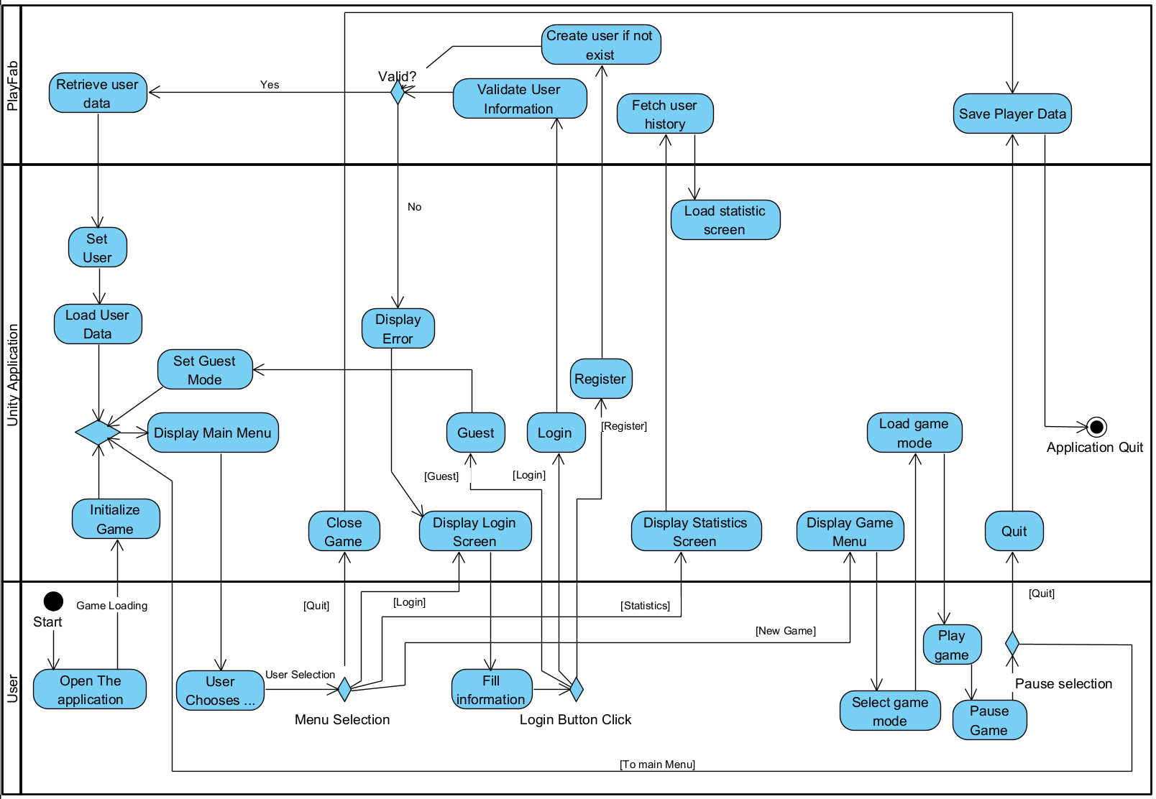

Diagram Overview:

1. Login: The player is logged into the game (optional) if the player wants to keep his progress available on multiple devices he may log in to a playfab account, this is optional, if the user decides no to log into a playfab account his game progress will be stored locally.
2. Game Mode Selection: the player will decide what game mode he wants to play out of 3 available game modes: Arcade, Learning.
3. Difficulty Selection: The player will select a difficulty if the mode supports it
4. Game paly: The player will start a game in the mode and difficulty he has selected and will resume the progress from the previous session in the relevant modes.
5. Pausing the game: The player may stop the game to edit his settings or save the game and return to the main menu or return to the desktop.
6. Learning Mode: in learning mode the player will be able to select the word he wants to practice and then will have a chance to try and practice it in front of his camera using our model.
7. Arcade Mode: In Arcade mode the player will face an arcade style interface that allows him to solve specific challenges.

## 2.6 Testing plan

### 2.6.1 Usability Testing

The testing plan is designed to ensure the quality and effectiveness of the application and the sign recognition feature. By thoroughly testing each of these elements, we can identify any potential issues or areas for improvement. We tested our games usability to assure that it is playable and intuitive, we found that the accuracy of our detection system works best when the user is about a meter away from the camera since that is how the recordings that were fed to the models are.

|  |  |  |  |  |
| --- | --- | --- | --- | --- |
| Test No. | Test Name | Tested Functionality | Expected Result | Status |
| 1 | Scene Loading | Test that the all the scenes are loaded correctly without missing elements. | The scenes should load correctly and without any errors | Pass |
| 2 | Scene Transitions | Test all the buttons in the game to assure they are leading to the correct places. | The transition between scenes should be quick and seamless | Pass |
| 2.1 | New Game | New Game should bring the user to a screen that has the available game modes | See a game menu with the options Learning, Arcade, and back to the previous menu | Pass |
| 2.2 | New Game -> Learning | Test that the learning mode scene is loaded | The learning scene is loaded, the buttons are clickable and lead to the learning screen for each button. | Pass |
| 2.3 | New Game -> Arcade | Test that a menu with the options to load arcade mode is opened. And there is an option to return to the previous menu. | Pressing arcade button will display the available arcade modes, currently “sign rush” | Pass |
| 2.4 | New Game -> Arcade ->  Sign Rush | Test that clicking on sign rush button loads the sign rush scene in the main menu | Opening the sign rush scene successfully. | Pass |
| 2.5 | Statistics | Test that clicking on the statistics button in the main menu opens the statistics scene | Statistics scene is opened successfully | Pass |
| 3 | Game Modes | Ensure all game modes are functioning as intended | All game modes should work correctly. | Pass |
| 3.1 | Learning | Test learning mode | Test the operation of learning mode | pass |
| 3.1.1 | Learning ->  Selecting word | Selecting a word by clicking it should open the next scene that shows the learning for that word | Learning screen for the specific word should appear | pass |
| 3.1.2 | Learning ->  Selecting not learned word | Selecting not learned word should display a video first to allow the user to learn the video.  Test that the buttons work correctly, play, pause, seek, close | A view with the videos should appear, all buttons should work, closing the window should bring the user back to the screen that allows him to practice the word | pass |
| 3.1.3 | Learning ->  Selecting learned word | Selecting learned word should display a screen that has the players camera feed and allows him to try and practice the word. Test clicking on learn to watch the video | A view with the camera feed should appear and allow the user to practice the word. Clicking on learn button should open the window in test 3.1.2. presenting the correct sign 3 times will mark the sing as learned with a star | pass |
| 3.1.4 | Learning ->  back | Back button in the main learning screen should bring the user to the main menu | Pressing on back button brings player to the main window | pass |
| 3.2 | SignRush | Test that the sign rush mode works correctly | Sign rush modes should operate perfectly. | pass |
| 3.2.1 | SignRush ->  Start | Test that the start button starts a new game. | A new game should be started | pass |
| 3.2.2 | SignRush ->  Back | Test that the Back button should brings the user to the main window | Pressing the back button closes the sing rush scene and opens the main menu | pass |
| 3.2.3 | SignRush ->  GamePlay -> instruction button | Test that the instruction button opens instruction panel. Test in the initial countdown and during the gameplay. | An instruction panel should appear, timer should be stopped. | pass |
| 3.2.4 | SignRush ->  GamePlay ->  Skip Button | Tesh that Pressing the skip button should increment the number of the word presented and should show a new sign | Pressing the skip button incremented the word counter and changed the current word | pass |
| 3.2.5 | SignRush ->  GamePlay ->  Presenting a sign | Test that presenting the correct sign increments the word counter and changes the word | Presenting the correct sign should incremented the word counter and changed the current word. A score should be added based on the response speed | pass |
| 3.2.6 | SignRush ->  GamePlay ->  Game complete | Test that Completing a game presents the score with starts that are full relatively to the score, the score is out of 1000 | Completing a game presents a score to the player and allows him to play the game again | pass |
| 3.2.7 | SignRush ->  GamePlay ->  Retry | Test that the retry buttons in the pause menu and the game complete menu start a new game with a score of 0 and the word indicator should turn to 1/10 | Clicking the retry button start a clean game. | pass |
| 4 | Correct Recognition | Test that when presenting a word the model recognizes it correctly, can be tested in the model preview when running with –show_video or within learning mode | The system should recognize the signs correctly | Pass |

## 2.7 Challenges

### 2.7.1 Multi Process Web Camera Access

One of the challenges we faced was is the access to the web cam, by default only one process can access the web cam at a time, for our use we needed the camera for our model to run, but it also mad a lot of sense that the user should be able to see himself while playing to assure that the camera captures his hands and that he is within the frame.

Our solution for this problem was to run a single thread that would access the camera and write its feed to shared memory, this shared memory then could be read both by our model and both by our game and thus resulting in a high speed and quality feed for both of our components.

# 3. User Guide

Recommended System Requirements

* Memory: 8 GB
* Graphics card: Nvidia GTX 960 or newer.
* CPU: Intel I5 6700 or newer.
* Hard Drive Space: 10 GB
* OS: Windows 10 or newer

Using older hardware is possible but we can’t assure smooth gameplay.

## Getting Started

1. Download Angel Hands from our GitHub Release Page: [Link](https://github.com/EitanGerman/Angel-Hands-Sign-Language-Learning-Game/releases)
2. Run the installer and follow the on-screen instructions
3. Once installed Launch "Angel Hands.Exe" from the desktop or start menu.

The user manual will include two parts:

1. Trainer application Guide.
2. Unity Game Guide.

## 3.1 Angel Hands Unity Game

**Main Menu:**

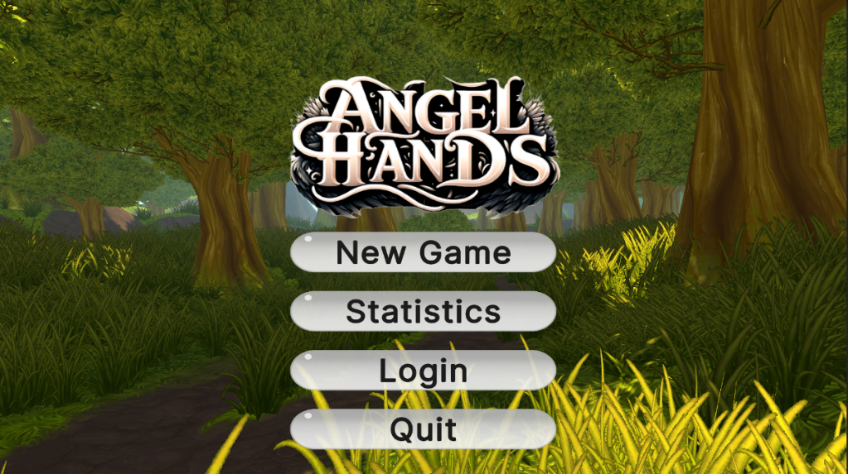

The first screen presented to the user when the game starts, the user can paly a game, view statistics, login or logout and quit to the desktop.

**Game Mode Selection:**

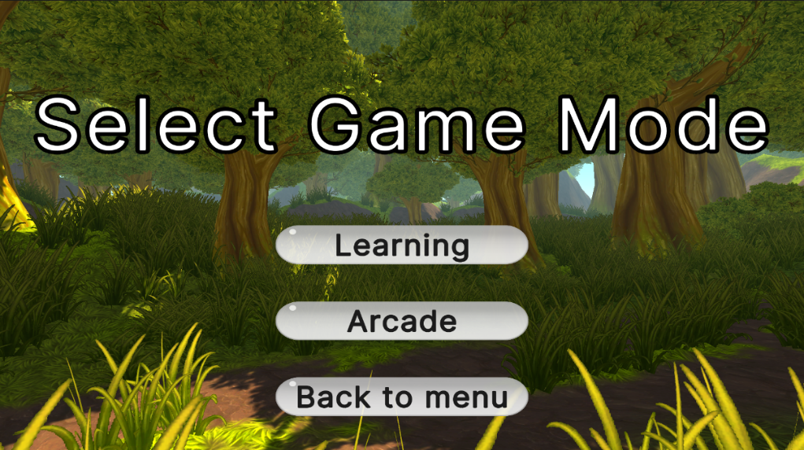

Clicking on New Game in the main menu will get the user here when he can choose out of two currently available modes. More modes can be added later to create a better experience.

**Learning Mode:**

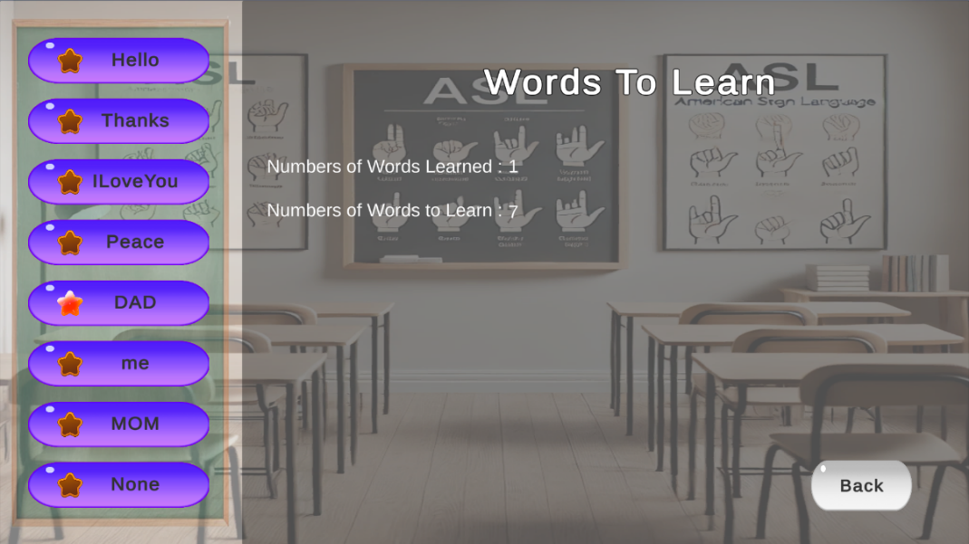

At the left there is a list of the words the model knows, the list is scrollable using the mouse scroll wheel or a scroll gesture, If the star is empty that means that the user has not learned that word yet, if the star is full that means that the user has learned that word already.

**Learning a word:**

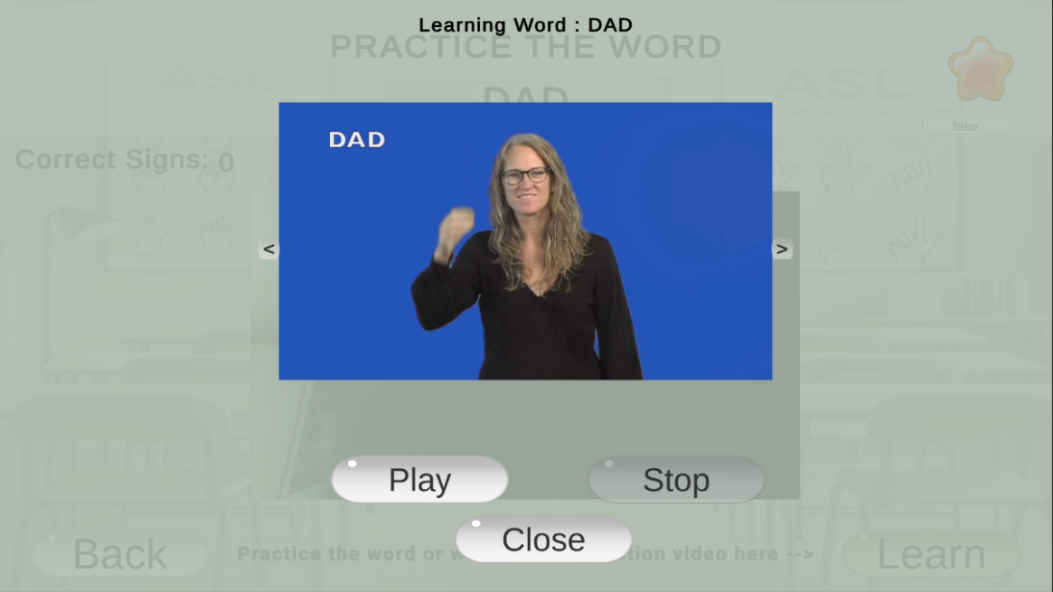

If the player has not learned the word, he will be presented with a window like this when he clicks on the word, the user can watch the video as many times as he wants, some words have multiple videos that can be scrolled using the arrow buttons at the right and the left.  
after closing the window we can practice the word we just learned.

**Word practice:**

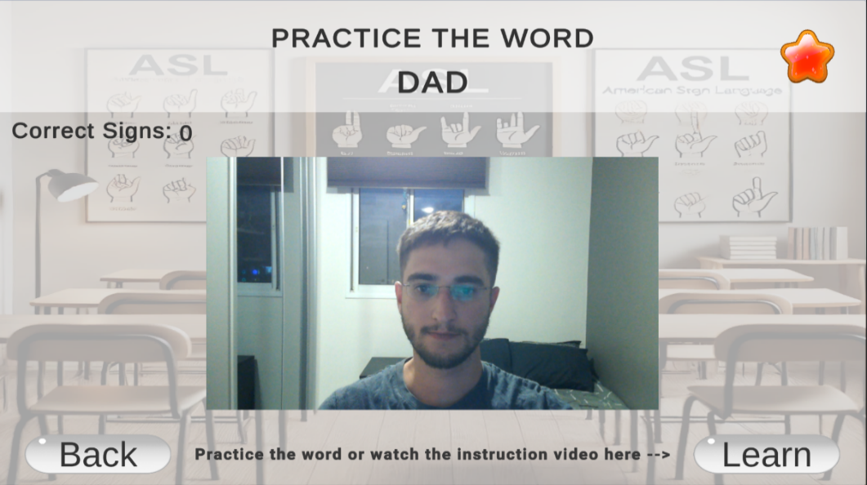

After learning a word, the user can practice it here, the player needs to sign the word correctly three times consecutively in this screen to mark it as learned. This will be indicated by a full star and the counter at the left of the screen that count the number of times the sign was presented correctly in this current session.

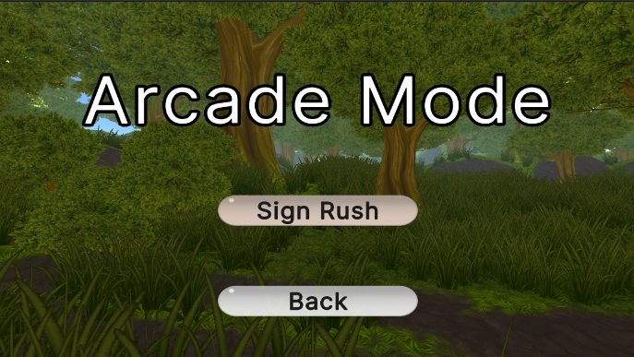**Arcade Mode:**

Selecting arcade in the main menu will bring the user to this screen, here he will be able to select the arcade mode he wants to play. Currently only “sign rush” is available but more modes can be added in the future.

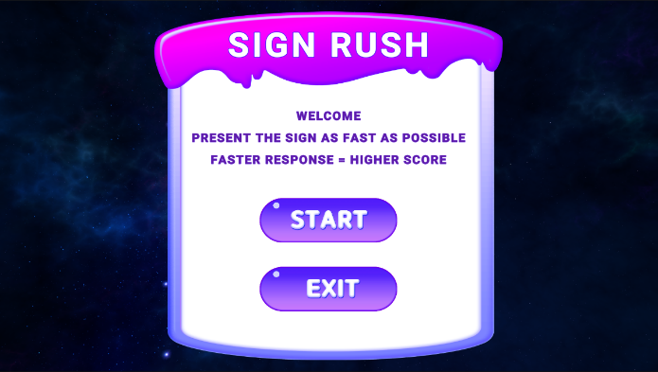

**Sign Rush:**

**The main sign rush screen:**

The user can start a game.

The user can return to the main menu.

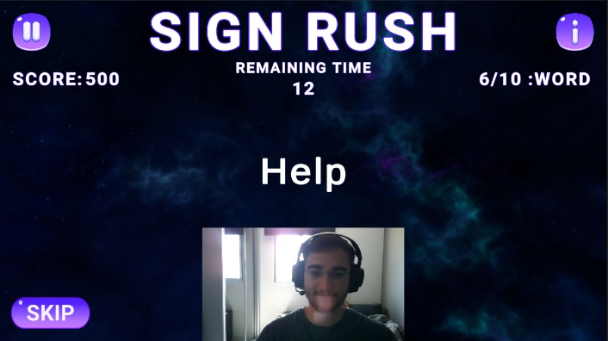**The Game Play Screen:**

The user needs to present the sign that is written in the middle of the screen as fast as possible, the user is allocated 20 seconds to present the sign as stated In the remaining time timer, the faster he answers the higher the score he gets for that sign (out of 100).  
when the clock runs out the user is shown the next sign to present. The skip button marks the   
as skipped and moves over to the next word.

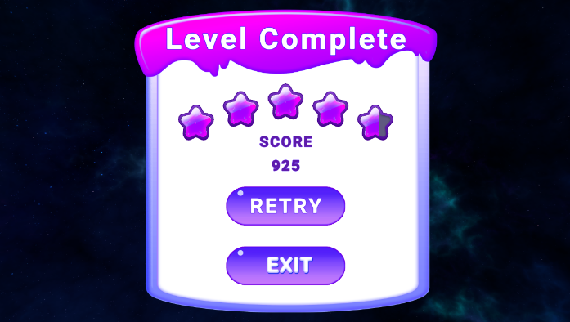**Level Complete:**

When the clock runs out or the user presents ten correct signs the level is complete and a score is shown along with a score in stars.

The user can return to the main menu.

The user can retry the game again.

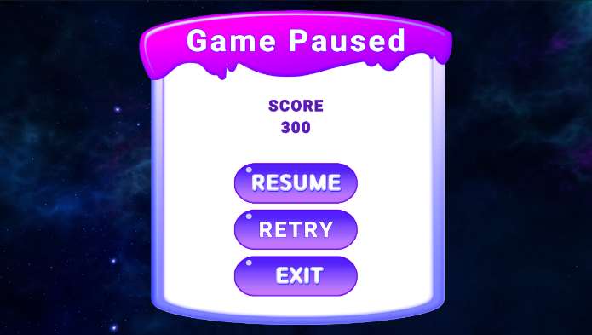**Game Paused:**  
The game can be paused, here the player can see his score. Resume the game where he paused or start a new game.

The user can return to the main menu.

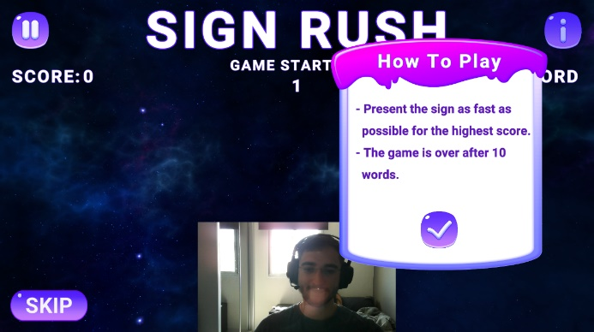

**Help Menu:**

While playing the game the i button can be pressed to learn how to play the game.

Opening the guide stops the timer and the timer start back up when the ok button was pressed.

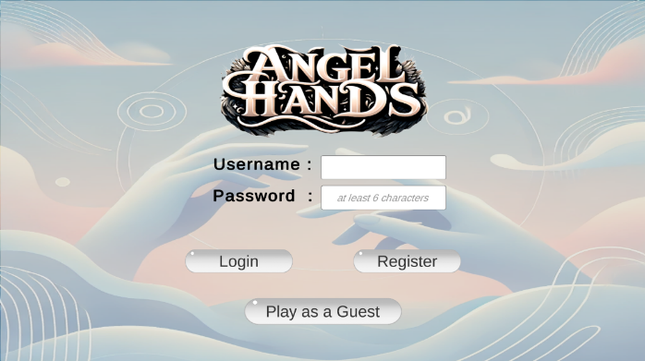**Login Screen:**

When Clicking login in the main menu the user will be presented with this screen, here he will be able to register or login with his existing account, he can also play as a guest and all the progress will be saved locally.

Filling the fields and clicking the register button will register the user into the game and he now can log in with these credentials.

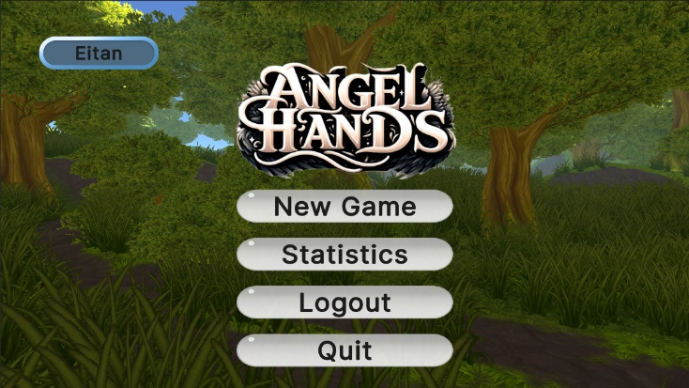**Logged in Player:**

When the player is logged in he will be able to tell by the blue bubble at the top right of the main screen that indicates his user name. he will also be able to logout by clicking the logout button.

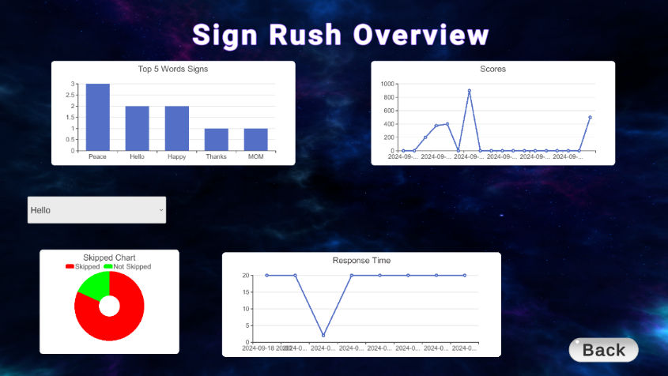**Statistics screen:**

The player will be able to watch his gameplay statistics.

At the top part of the screen he will be presented with the top 5 words that he is doing the best. Along with a chart of the score he got for each time he plays the game. The statistics will be per game mode (currently only sign rush available).

in the dropdown menu he will be able to select a word and watch specific statistics for that word, we show how fast he presented that word since that is the only metric we can get from the model as it is designed today.

The back button returns the user to the main screen.

## 3.2 Model Trainer Application

We designed an amazing application that would allow us to collect data using multiple methods and training a model on the signs we want.

### Setting up the trainer application

1. To set up the Trainer application first clone the git repository.

You can find it Here: [Link](https://github.com/EitanGerman/Angel-Hands-Sign-Language-Learning-Game)

1. Open the AslTrainerApplication Folder.
2. Create a virtual environment if you want, end then install all the required libraries that are listed in the requirements.txt file found in the root of the trainer application folder.
3. Then locate the AslTrainerApplication.py python file and run it. This will launch the application and will get you started.
4. Follow the instructions below to collect data, train and test the model.

### 3.2.1 Data Acquisition methods:

1. **Collecting data from the user's camera:** the user will enter the name of the sign he wants to train the model and then he will record himself 30 times presenting the sign. It is important to try to make it a little different each time from different distances away from the camera and slightly different poses. In order to select a folder, the user must first create the folder using the folder manager tab that we will explain later.

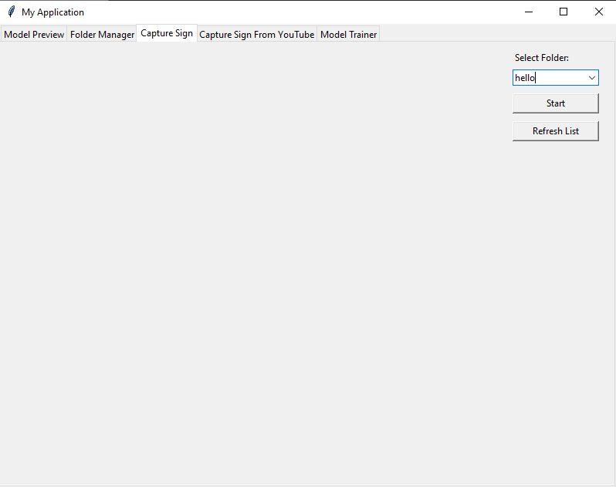

1. 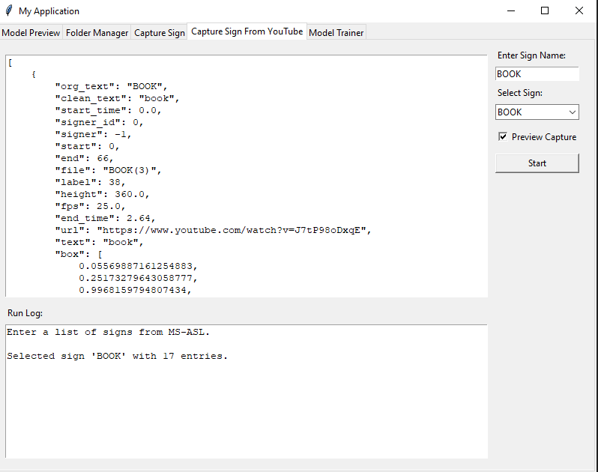**Collecting data from YouTube:** the user will select the word he wants to collect data about from a list, the list was composed form all the signs that are available in the MS-ASL dataset. It is also possible to provide the list manually by entering it in the correct format in the textbox or modifying the data from the MS-ASL dataset as you seem fit.

When clicking on preview it is possible to see the YouTube video playback as the application collects the data for training.

We also can see that the word “Book” has 17 entries that means that the 30 captures will be split between them to reduce overfitting, we would rather select signs that have as many different videos as possible.

* We strongly recommend watching the recording process since the signers in the videos often show different angles within the same section or make markings with their other hand to emphasize something, while this is useful for human learning it will confuse the model since it will expect that exact pattern, feel free to open the videos and minimize the recorded part only to the part that you are interested in since that will significantly improve the models accuracy. This can be done by modifying the “start_time” and “end_time” fields in the window you see above. Do this for all the videos to ensure that only the wanted parts are recorded.

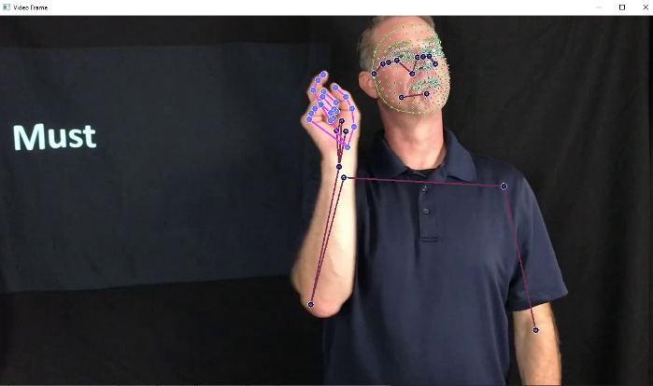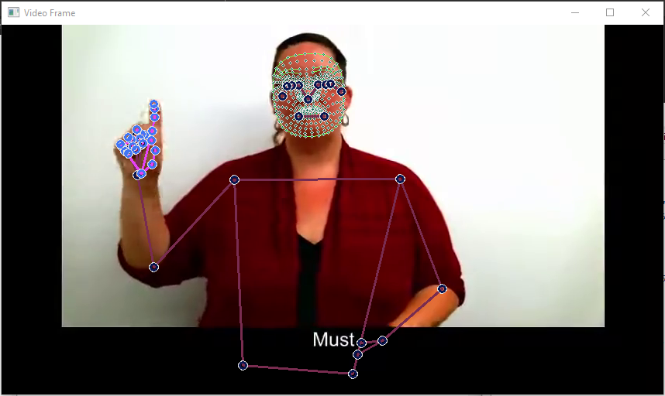

Collecting the data may take some time since it relies on your network connection to download the videos before training on them, it also deletes them when its done to avoid overfilling your hard drive. It is possible that signs in this tab will fail to fill because of unavailable links or incorrect data in the dataset, if there is at least one good recording the code will fill in the blanks by randomly duplicating good recordings, if all links fail to download or provide a viable video, the folder will remain empty and it will not be possible to select it for training. Although the main videos are deleted. Short snippets of the sign are kept to later be displayed in the learning mode in our game. We also keep the links for those videos to provide the user the ability to learn by himself from different sources and to provide credit for the creators of the YouTube videos. These links will be available for the user to open from within the game.

### 3.2.2 Data management

We can now navigate to the tab named Folder Manager. This tab will allow us to see what signs we have recorded and select them, we then click on save selection to allow us to train on that list. It is also possible to create a folder for the “capture sign” tab that would then be used to collect the data into it. There is an option to delete a folder by clicking delete.

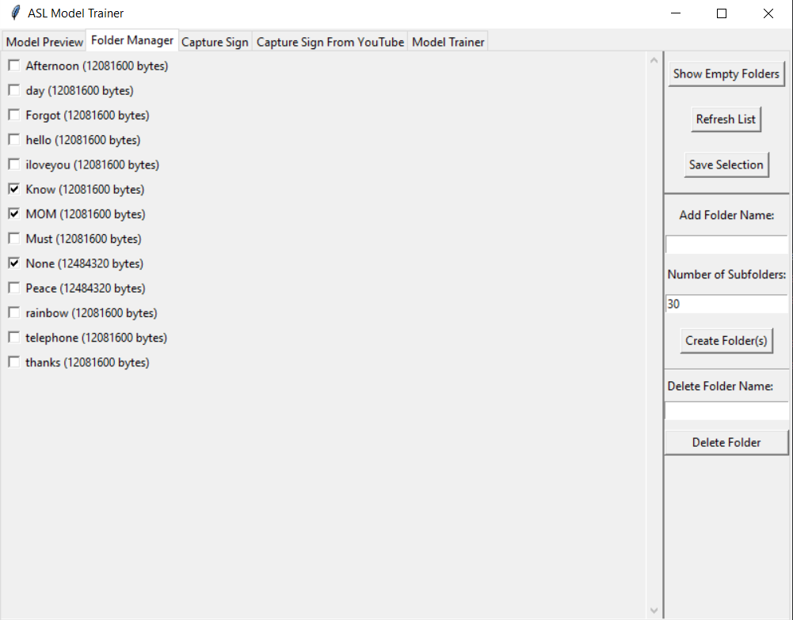

### 3.2.3 Training the model

Navigate to the “Model Trainer” tab. Then click the refresh button to load the list we just saved in the previous tab. We can now select the number of Epochs and the train test split for the model. With some trial and error, we picked 300 Epochs with a train test split of 0.1, this can be changed by the user if we don’t get good results from training the model.

Clicking on "Refresh List" will load all the words that were selected in the "Folder Manager" tab and they will appear in the Folders to train list.

Clicking on Run Training will start training the model. This could take a while based on the number of sighs that was selected.

At the end of the training there is an evaluation process where we get the categorical accuracy of the current model training session, we would consider anything above of score 85 as a good result, we would prefer the highest results possible and sometimes we need to tinker with the number of epochs and the split based on the number of words we want our model to know.

The model is saved within a folder that its name is the timestamp (date and time) of the training.

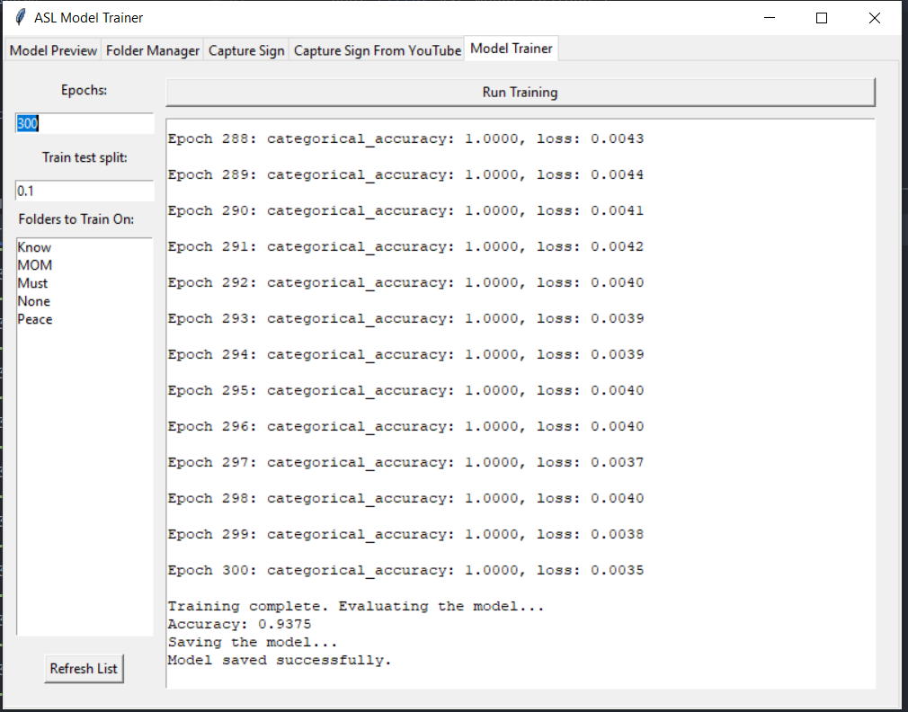

### 3.2.4 Testing the model

Navigate to the Model preview tab, in this tab you will be able to select a model folder with the model. We automatically added a list of all the models we trained, we also have a list that contains all the words this specific model was trained on. Refreshing the list will select the latest model we have. And starting the model will open a window with the camera feed and the predictions of the word that is shown. This can be used for debugging and testing.

To close the window, click on ‘q’ on the keyboard.

There will also be a blue bar at the top that tracks the history of the words we presented.

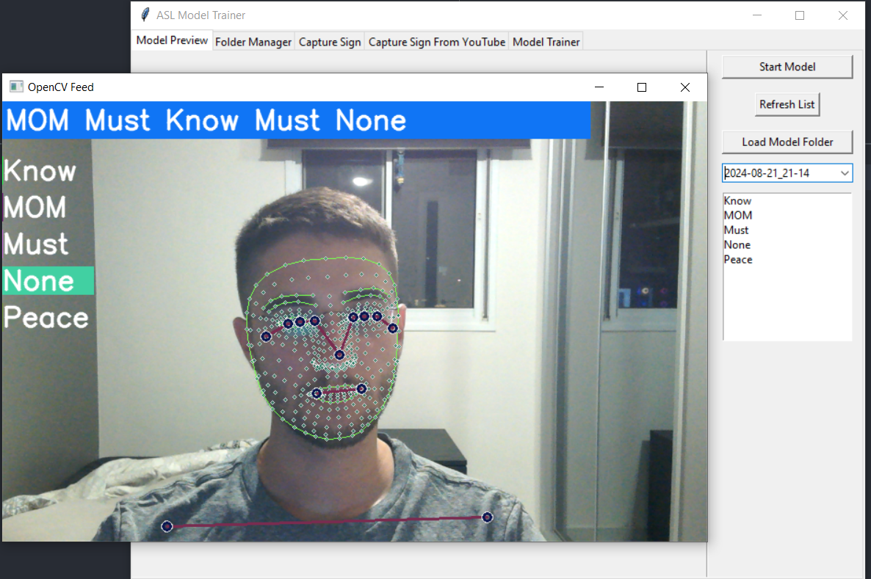

### 3.2.5 The ASL Recognition Service

The last piece of the puzzle would be the actual application that will run in the background and detect the signs. It can be run from command line or form other code. It takes three parameters. Four of which are optional, a model path should be provided, and it’s possible to choose to preview the video feed, it is possible to alter the communication port and the width and the height of the camera video feed.

This is an example of how the code can be called:

ModelServer.exe Models/2024-08-04_19-29(500EP) --show_video --server_port 22761 –Width 640 –Height 360 –Threshold 0.6 –Sensitivity 8

This will start the model withing the Models/2024-08-04_19-29(500EP) folder.

--show_video will display the preview like in the model preview in the application.

--server_port 22761 will start transmitting the signs on port 22761 as soon as there is a connected client.

--Threshold is a value between 0 and 1 that defines the models detection threshold. The closer the value is to 1 the more the model must be sure of the sign, (Higher numbers mean the game might be less playable) we set the default to 0.7.

-- Sensitivity is a integer between 1 and inf, it determines how many times in a row the model has to predict a sign before sending it to the game

–Width 640 –Height 360 set the video feed to a resolution of 640 by 360 which is a 16:9 aspect ratio.

### 3.2.6 Extra

Although the Application is quite extensive with logs within it, we were not able to bypass all the output that get printed to the console into the application so the best practice would be to run it form within PyCharm to see all the information.

# 4. Maintenance Guide

## 4.1 Game Maintenance

### 4.1.1 Updating the sign language Model

The model is stored at a predefined location within the game,

AngelHands\Angel Hands_Data\StreamingAssets\ModelCommunication\ActiveModel

updating the model file with new words is as simple as replacing the files in that directory with files from the newly generated model, now the new words are available and can be used within the game. Note that it might not be sufficient as this will only allow the detection of the signs and might need further development according to the mode you’re in to get the most of the newly added words. Creating a new model file is described in the user guide in section "3.2.3 Training the model". After refreshing the page with the newly added words from the select folders tab, it is possible to run training, training results in the creation of a new model file along with metadata that can be used within the game to learn the models’ capabilities in the sign language.

### 4.1.2 Expanding the game

Adding new game modes is simple. Just create the new scene as you want and map it to one of the buttons in the game menus, more game styles and modes can be added. For some there is already a preparation in the UI documents. In the home screen there is an element named UI, to this element there are some attached ui documents that can be edited, the code is common for all of them, when adding a b new button don’t forget to name it with a unique name sine that will be name you are looking for in the ui manager for the home screen.

### 4.1.3 Game Modules

The game is composed of many modules. We created some main classes that can be used to make the development easier.

GameManager: is a class that is used to join all the parts together, it’s a singleton class that will be in charge of on initiating some of the components. It will hold the word that is received from the model application that transmits the detected word over tcp.

It is in charge of initializing the sign language recognition application.

Initializing the sign language recognition application will be done through a class named ExternalProcessManager. This class will load and run the model.

The models data is accessible over the port that defined to it upon runtime through the command line parameters. This application will also run the SharedMemoryPlugin that would allow us to access the camera from multiple processes by just accessing the shared memory mapped file that the model creates.

External process Manager runs “ModleServer.exe” in the following path:

AngelHands\Angel Hands_Data\StreamingAssets\RuntimeModel

This file only needs to be updated if there are changes to the model’s code.

### 4.1.4 PlayFab Database and login API

We searched for a service that will help us to enable to users to log in for different devices and keep their progress. We encounterd Google's API for Unity which contains firebase as data management and enabling to log in using google account, due to changes in google API recently that made it an unfitted solution we had to continue and search for a new solution that will be as good as googles service. We found PlayFab which is well know alternative that is used by many popular video games like Doom:Eternal, Microsoft Flight Simulator, Minecraft and more.



PlayFab is a backend platform for building and managing live games. It provides tools and services like player authentication, multiplayer server hosting, data analytics, leaderboards, in-game purchases, and more, allowing developers to focus on game features rather than server infrastructure. PlayFab is owned by Microsoft, which acquired it in 2018 to enhance its Azure cloud services for game developers.

"Angel Hands" takes advantage of using PlayFab for User management (player authentication and storing in-game users' data - ASL words a user learn with their statistics).

We Created a project in [Azure PlayFab](https://developer.playfab.com/) where we can manage the service and monitor it.

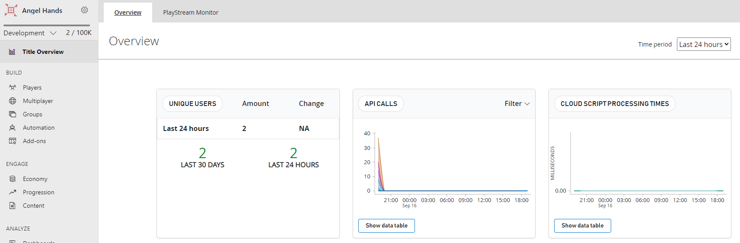

PlayFab provides an API for unity where we can use all PlayFab capabilities.

For Example – Login Scenario:

We created a Login /Register screen using PlayFabClientAPI library. We send requests to our PlayFab Project with a dictionary which represent the request and providing 2 functions one that will be called upon succession and other for Failure of the request response.

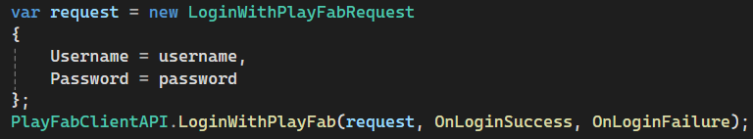

We Defined functions named "OnRegisterSuccess" for succession, "OnRegisterFailure" for Failure. Based on the results we modify the status of the player, send output to the user using the Screen if needed and proceeds with the game flow.

Each User once logged in can use his in-game data, thanks to PlayFab and we can monitor that data and test it via Azure PlayFab Web.

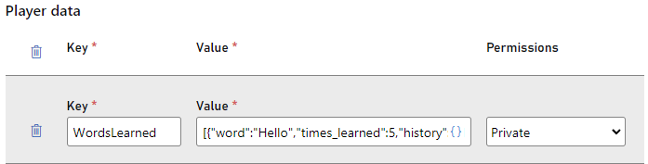

The data is sent and received via PlayFab API as JSON format.

PlayFab helps us to enable user to play from different devices and monitor the users, but it has **limitations** due to that we are using the **Free Version**:  
**User Capacity limit of 100K** (which is more than enough for our state).

**Retains data from the last 30 days** which is problematic, but we do have a solution in mind for it (for developing state it's enough).

**Up to** **1 million API calls per month**.

**Features are locked to the paid version**.

Thanks to PlayFab we can focus on the game development, we do have to consider our limitations, but it still has a great value for development stages and usage for small audience.

## 4.2 ASL Model Maintenance

Clone the repository stated before in the user manual.

### 4.2.1 Main Application

The main application is AslModelTrainerApp.py, this class holds the main tab Notebook for the ui. In this file you can add new views if you want.

* Install all the libraries in the requirements.txt file in order to run the application form PyCharm.
* We strongly recommend using PyCharm as the paths are designed around the relative path definition in PyCharm and may need to be modified to work from other environments.
* The views are located in the **views** folder where each file represents a tab in the main application.
* The **common** Folder holds tools we used throughout the development and holds common code used by many classes.

It also contains the SourceData folder that has the file that was generated from the MS_ASL dataset to group common signs together in a list for easy parsing and access.

* The **Models** Folder contains the trained models. Where each model has the action.keras file that holds the weights of the trained model and can be loaded quickly for testing and running the recognition model. It also has a file named selected_folders.txt that contains all the words that this specific model was trained on. Do not change this file as it is used as an info file and will not affect anything if changed.
* The **MP_Data** folder has all the data collected about each sign, it is composed of subfolders that represent signs and the sign folders contain 30 folders where in each there are 30 .np files that represent the arrays generated by google holistic.

When training the model this information is loaded.

All the generated models are saved and may be used in the game, keep in mind that certain worlds may require specific words. the best practice would be to add new words rather than removing others.

See the user guide in section 3.2 to learn how to use the application itself.

# 5. Results & Conclusions

We ended up with a game that is both educational and fun at the same time. It is versatile and can be improved and expanded with ease.

The complementary application to train and test the model is quite unique as it allows straightforward expansion and with the use of TCP for sending the results can be attached to nearly any application. And thus, remain relevant even without the game itself.

We have achieved most of our criteria for success and we are sure that with more time and experience in unity development we could create better and more immersive worlds.

* Collecting the data for the model proved to be the main hurdle for us and its recommended to record words with as many entries as possible for the best accuracy.
* Camera position is important.

## 5.1 Further Improvements

* More worlds should be added to the game with various new ideas to keep the game interesting and relevant for the future. We only added a few since each one takes some time and thought to design a world that would be fun to play in.
* The model seems to be a bit more accurate when there are less worlds if trained by data that is not good enough. Perhaps it is possible to train many models dedicated to each world and run them when loading the world instead of using one big model.
* Add a method to help the player position himself a little better before starting to play.

# 6. References

1. [Gee, J.P. (2003). What video games have to teach us about learning and literacy.](https://blog.ufes.br/kyriafinardi/files/2017/10/What-Video-Games-Have-to-Teach-us-About-Learning-and-Literacy-2003.-ilovepdf-compressed.pdf)

2.[Oviatt, S. (1999). Ten Myths of Multimodal Interaction.](https://dl.acm.org/doi/10.1145/319382.319398)

3.[Starner, T., et al. (1998). Real-time American Sign Language recognition using desk and wearable computer based video.](https://www.researchgate.net/publication/3192935_Real-time_American_sign_language_recognition_using_desk_and_wearable_computer_based_video)

4.[Meng Wu (2024). Gesture Recognition Based on Deep Learning: A Review.](https://www.researchgate.net/publication/378817255_Gesture_Recognition_Based_on_Deep_Learning_A_Review)

5.[Nick Barney (2023). Gamification.](https://www.techtarget.com/searchhrsoftware/definition/gamification)

6.[Fadhlina Izzah Saman, et al. (2019). Sign Language Learning Application Via Gamification.](https://eric.ed.gov/?id=EJ1238764)

7.[What Is American Sign Language (ASL)?](https://www.nidcd.nih.gov/health/american-sign-language)

8.[How to learn sign language the best way – HandSpeak](https://www.handspeak.com/learn/7/)  
9.American Sign Language - [pic link](https://en.wikipedia.org/wiki/American_Sign_Language)

10.[Unity (game engine) , Wikipedia.](https://en.wikipedia.org/wiki/Unity_(game_engine))

11.What is Unity - <https://twitter.com/AaronChurchgcc/status/1591048109077168130>

12. [Holistic landmarks detection task guide](https://ai.google.dev/edge/mediapipe/solutions/vision/holistic_landmarker)

3. [Pose landmark](https://ai.google.dev/edge/mediapipe/solutions/vision/pose_landmarker)

4. [Hand landmarks](https://ai.google.dev/edge/mediapipe/solutions/vision/hand_landmarker/index)

15. [Face Landmark](https://ai.google.dev/edge/mediapipe/solutions/vision/face_landmarker)

16.[Sign Language Recognition Application Using LSTM and GRU (RNN)](https://www.researchgate.net/publication/369857149_Sign_Language_Recognition_Application_Using_LSTM_and_GRU_RNN)

17.[American Sign Language Recognition Using Machine Learning and Computer Vision](https://digitalcommons.kennesaw.edu/cgi/viewcontent.cgi?article=1024&context=cs_etd)  
18.[Gamification By Nick Barney](https://www.techtarget.com/searchhrsoftware/definition/gamification)

# 7. GitHub Link

[Angel-Hands-Sign-Language-Learning-Game](https://github.com/EitanGerman/Angel-Hands-Sign-Language-Learning-Game)

1. [Pose landmark](https://ai.google.dev/edge/mediapipe/solutions/vision/pose_landmarker)
2. [Hand landmarks](https://ai.google.dev/edge/mediapipe/solutions/vision/hand_landmarker/index)
3. [Face Landmark](https://ai.google.dev/edge/mediapipe/solutions/vision/face_landmarker)